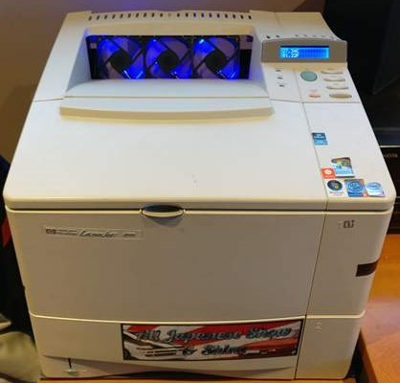

Custom Server Workstation

Jonathan Parkes

# Introduction

This project was built with the intent to create a workstation out of retired server components with good performance for very little money. The reason for doing this was that I wanted to low cost workstation as well as to show you do not need to buy flashy new components to build a good computer.

# Specifications

### CPU

* 2x Intel Xeon X5670
  + Cache Memory: 12 MB
  + Processor Base Frequency: 2.93 Ghz
  + Max Turbo Frequency: 3.33 Ghz
  + Bus Speed: 6.4GT/s QPI
  + Number of Cores: 6
  + Number of Threads: 12
  + Socket: FCLGA1366
  + Compatible Primary Memory: DDR3 800/1066/1333MHz

### RAM

* 4GB Micron PC3-10600R
* 4GB Hynix HP 500203-061 PC3-10600R
* 2X4GB New SAMSUNG PC3-10600R
  + DIMM Speed: 1333MHz
  + DIMM Interface: DDR3
  + DIMM Type: ECC Registered

### Motherboard

* SuperMicro X8DTL-3F rev2.01 Motherboard server board Dual LGA 1366 Sockets DDR3
  + Dimensions: 12” by 10”
  + Processor chipset: dual 1366 LGA socket
  + Supported Processors: Xeon 5500 series and Xeon 5600 series
  + Memory Capacity: Supports up to 96 GB 1333 / 1066 / 800MHz DDR3 ECC Registered memory or Supports up to 24 GB 1333 / 1066 / 800MHz DDR3 ECC / Non ECC Unbuffered memory
  + Fans: 6x 3 pin fan header
  + Expansion Slots:
    - 2 (x8) PCI-E 2.0 (1 in x16 slot)
    - 1 (x4) PCI-E 2.0 (in x8 slot)
    - 1 (x4) PCI-E (in x8 slot)
    - 2x 33MHz PCI slots
  + I/O Ports:
    - 8 SAS / SATA ports
    - Six Serial ATA ports
    - Six SATA hard drives supported
    - 2x RJ45 LAN ports
    - 1x RJ45 Dedicated IPMI LAN port
    - Total 5 USB 2.0 Compliant
    - PS/2 keyboard and mouse ports
    - 1x VGA Port
    - 1 Fast UART 16550 serial port
    - 1 Fast UART 16550 serial header

### PSU

### Video Card

### Cooling

### Case

* Laserjet 4000 printer
  + Internals removed
  + Internal structure modified to accompany parts
  + Custom raised mother board mounts

### Arduino

* Hardware:
* Purpose: The purpose of the Arduino was to monitor the ambient temperature of the most likely warmest point on the computer (behind the graphics card) as there is not much air flow in that location it will give an upper bound for the ambient temperature.
* Code:

# Cost

* CPUs: Price per unit = $28.92

Shipping = $19.28

Total = 2x $28.92 + $19.28= $77.12

* GPU: Prince per unit = $60

Shipping = $0

Total = $60

* PSU: Price per unit = $109.99

Shipping = $5

Total = 114.99

* Mother Board: Price per unit = $97.39

Shipping = $0

Total= 97.39

* RAM: Price per unit = 1x $10.27, 1x $12.84, 2x $8.29

Shipping = $0

Total = $10.27 + $12.84 + 2($8.29) = $39.69

* CPU Cooling: Price per unit = 2x $25.57

Shipping = $0

Total = $51.14

* Ambient Cooling: Price per unit = 4x $4.25

Shipping = $ 0

Total = $17.00

* Case: Price per unit = $20.00

Shipping = $0

Total = $20.00

* Hard Drive: Price per unit = $0

Shipping = $0

Total = $0

**Total** = $77.12 + $60 + $114.99 + $97.39 + $39.69 + $51.14 + $17.00 +$20 +$0

= $477.33

# Design

The design of this computer was important to keep it cool and to make sure everything would fit inside the custom case. The first step of the design was to make a raised mount for the motherboard. To do this I used a series of long bolts with washers and nuts. First I mapped the board mounting locations onto the flooring of the case then proceeded to drill holes at each location and mounted the bolts through. Next was to determine how high to mount the board up, I decided on about one inch to provide lots of air flow under the board. The next step of the design was to plan how the air will flow though the machine for optimal cooling. The ideal orientation I was able to make was to channel the air flow into the center and then have that pushed out the back as seen in figure 1 bellow.

Figure 1

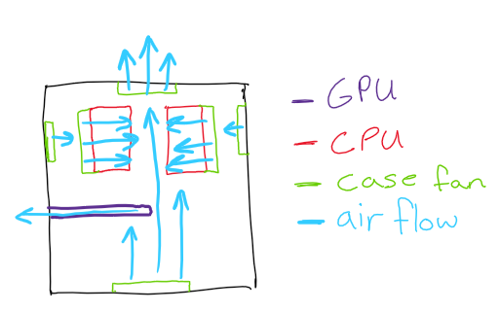

# Problems Faced

The major problems faced in this build was part orientation, cooling, and finding details on what each port and pin on the mother board was for. When building the internals, I found that the Hyper T4 CPU heatsinks were too large to fit in the desired orientation. Because of this the air flow direction had to be modified. The solution to this was to make both heatsinks air flow towards each other that then gets pushed out the back by the air flow going from front to back in the computer. Cooling was one of the biggest concerns when building the workstation because the external structure was not meant to accommodate a lot of fans. To get adequate cooling to the internals the original 1 fan from the printer was removed and the location was expanded to be able to fit a larger and more powerful fan. In addition to then the front panel was made to be removable with a black metal mesh behind it with a large fan pulling air into the system. This allows for increased cooling when doing more intensive tasks. The final Problem I faced in the build was finding the details of the mother board. The most difficult information to find the pins for the power and reset buttons, the order of the RAM slots, and the order of the SATA ports.

# Results

The workstation was booted windows 10 student edition successfully without conflict. When the system was booted up it was able to recognize both Xeon x5670’s, the GTX 760, and all the RAM. Performance of the system was shown to be very good in heavy CPU and GPU workloads. Cooling was seen to be effective in use sitting at 384u83 at idle and 45949 under heavy workload. Future improvements to the system will be a more space effective PSU location, a more powerful GPU to not bottleneck the system performance, run it as dual boot with a Linux distribution, and water-cooling for a more pace effective method to keep the system cool. The resulting conclusion is that it performs extraordinarily well for its components price compared to a similar performance machine out of new consumer grade parts.

# References

[1]"Intel® Xeon® Processor X5670 (12M Cache, 2.93 GHz, 6.40 GT/s Intel® QPI) Product Specifications", *Intel® ARK (Product Specs)*, 2018. [Online]. Available: https://ark.intel.com/products/47920/Intel-Xeon-Processor-X5670-12M-Cache-2_93-GHz-6_40-GTs-Intel-QPI. [Accessed: 10- Jan- 2018].

[2]"Super Micro Computer, Inc. - Products | Motherboards | Xeon Boards | X8DTL-3F", *Supermicro.com*, 2018. [Online]. Available: http://www.supermicro.com/products/motherboard/QPI/5500/X8DTL-3F.cfm. [Accessed: 10- Jan- 2018].